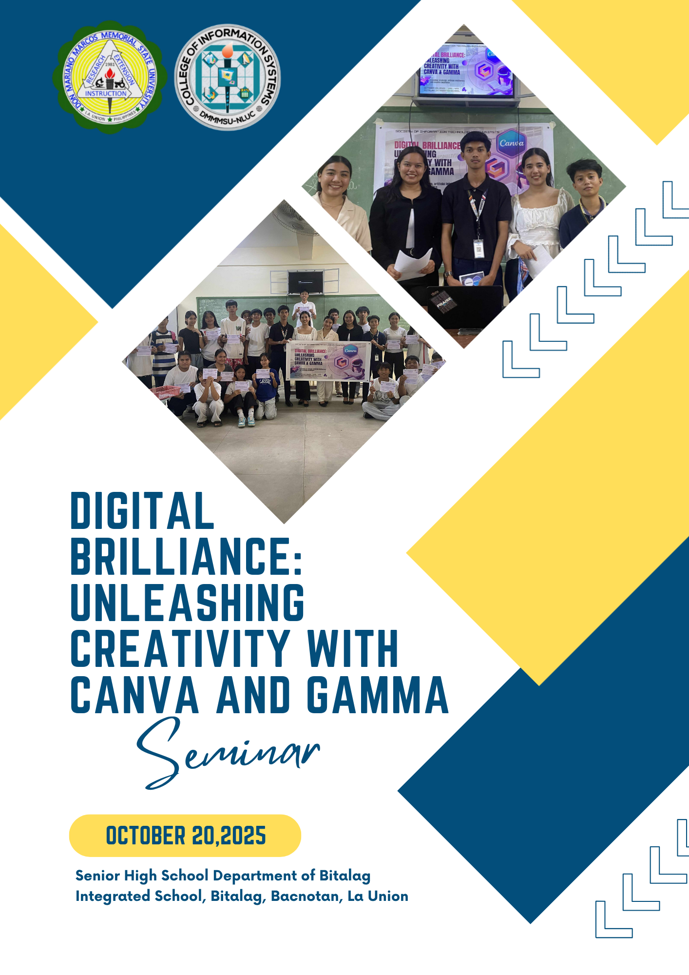

**TABLE OF CONTENTS**

|  |  |
| --- | --- |
|  | **Page** |
| I. TITLE PAGE | 1 |
| II. TABLE OF CONTENTS | 2 |
| III. PRELIMINARIES |  |
| Acknowledgement | 3 |
| IV. NARRATIVE REPORT |  |
| A. Narrative Report as a Group | 5 |
| B. Aerone B. Imbuedo | 8 |
| C. Irish Jingle A. Riñon | 9 |
| D. Jaira Mitch B. Riñon | 10 |
| E. Mhyca Joy N. Obra | 11 |
| F. Ika Ivana B. Licudan | 12 |
| V. APPENDICES |  |
| A. Approved Communication | 14 |
| B. Programme | 15 |
| C. Publication Material | 16 |
| D. Certificates of Resource Speakers | 17 |
| E. Certificates of Facilitator | 18 |
| F. Certificates of Participants | 19 |
| G. Attendance | 22 |
| H. Student Outputs | 23 |
| I. Photo Documentation | 24 |

**ACKNOWLEDGEMENT**

This seminar, "Digital Brilliance: Unleashing Creativity with Canva and Gamma," was made possible by the assistance, direction, and collaboration of people and organizations that valued information sharing and student empowerment. We are truly grateful to everyone who helped make this activity a success with their time, effort, and support.

We sincerely thank our campus chancellor, **Dr. Junifer Rey E. Tabafunda**, for giving us the chance to organize and direct this seminar. His confidence and encouragement enabled us to carry out our academic effort and disseminate important knowledge outside of the classroom.

We also appreciate **Dr. Edelita C. Ebuenga**, the dean of the College of Information Systems, for her advice and support. We are appreciative of her ongoing commitment to supporting student-organized educational activities, and her permission and attention were essential to the success of this seminar.

We would like to express our sincere gratitude to our subject teacher, **Dr. Rhoda M. Lilan**, whose guidance and mentoring helped shape the preparation and execution of this event. Her encouragement inspired us to tackle this task with responsibility, creativity, and purpose.

Also, we would like to sincerely thank **Ms. Jhonalyn B. Lardizabal**, Adviser of the Society of Information Technology Enthusiasts, for assisting us in fulfilling every requirement and preparations. Her help and willingness to assist made the process work more smoothly and efficiently.

We are very thankful to **Ma'am Larievic T. Pajimola**, Principal III of Bitalag Integrated School, for allowing us to hold the lecture there. Her cooperation and openness made it possible for us to offer this educational opportunity to the students at their school, and we are quite grateful for the positive response we got.

We would like to thank our seminar recipients, the **Grade 11 (Fortitude) TVL students** of Bitalag Integrated School, for their enthusiastic and active participation. Everyone participated found the conversation to be engaging, interesting, and significant because of their curiosity and want to learn.

Finally, we would like to express our gratitude to **the Society of Information Technology Enthusiasts (SITE)** for promoting our seminar on their Facebook site. Their contribution to the event's promotion enabled us to connect with our target audience and spread awareness of our purpose to reach more people.  
 We want to appreciate each and every one of you for your important support and participation. Without your participation and assistance, this seminar would not have been a success.

**NARRATIVE REPORT**

**DIGITAL BRILLIANCE: UNLEASHING CREATIVITY WITH CANVA AND GAMMA**

The seminar, "Digital Brilliance: Unleashing Creativity with Canva & Gamma," was successfully held on October 20, 2025, at the Senior High School Department of Bitalag Integrated School. Its goal was to provide Grade 11 TVL students with useful skills in digital design and modern presentation tools, which are crucial for academic assignments, work immersion necessities, and future career opportunities. Two significant seminars on the AI-powered presentation tool Gamma and the creative platform Canva were included in the program.

At 1:00 PM, the program officially started with participant registration, which was led by Ms. Mhyca Joy Obra. Students received help settling in and getting ready for the afternoon's educational activities. At 1:10 PM, the opening ceremony started. The session began with a respectful and motivating opening prayer led by Ms. Ika Ivana Licudan.  
 The emcee, Ms. Jaira Mitch Riñon, gave a summary of the goals and significance of the event before the speakers were formally introduced.

At 1:30 PM, an icebreaker game called "Pass the Creativity" was held in order to motivate and involve everyone present. With the goal to prepare for the ensuing seminar sessions, students actively and passionately participated, demonstrating creativity and teamwork.

Ms. Irish Jingle Riñon led the first session, which lasted from 1:45 to 2:15 PM. She gave a thoughtful overview of Canva, a popular online graphic design platform. She talked about key components that enhance digital outputs, including templates, layout principles, typography, color schemes, and visual components. Ms. Riñon highlighted how students may use Canva to create infographics, posters, school projects, and other visual resources. Students found it easy to implement what they learnt because of her session's clarity and relatability. From 2:15 PM to 2:35 PM, there was a hands-on activity where participants could make their own digital posters. Through their exploration of Canva's interface and use of the speaker's skills, students produced outputs that demonstrated their uniqueness and inventiveness.

At 2:35 PM, students were given a short break. During this time, the facilitators distributed snacks, giving the participants time to relax before the next learning session.

Mr. Aerone Imbuedo started the second major session at 2:45 PM by going over the capabilities of Gamma, an AI-powered presentation tool. He gave an example of how Gamma helps users produce polished, organized presentations quickly. Mr. Imbuedo emphasized how Gamma is a useful tool for students creating academic slideshows, reports, and other visual presentations because it can automatically generate content and layouts. His talk focused on increasing productivity and simplifying difficult activities, which is very helpful for TVL learners. Students made their own Gamma presentations during a practical exercise that ran from 3:15 to 3:35. As they explored the platform and used their recently acquired skills, they shown a great deal of interest.

Selected students presented their Gamma presentations and Canva posters at 3:35 PM. The results showed increased inventiveness, awareness of design, and proficiency with digital technologies. Following the presentation, there was a Q&A session where attendees could clarify ideas and ask the speakers more questions.

At 3:50 PM, the program came to an end with closing statements that appreciated the teachers, students, facilitators, and speakers for their support. A group photo was then taken to celebrate the seminar's successful operation.

For the Grade 11 TVL students at Bitalag Integrated School, the seminar titled Digital Brilliance: Unleashing Creativity with Canva & Gamma was a significant and fruitful event. Students learned a great deal about digital design and AI-assisted presentations from Ms. Irish Jingle Riñon and Mr. Aerone Imbuedo. These abilities are becoming more and more important in today's classrooms and in the industry of the future.  
 The program was seamless, well-organized, and engaging thanks to the cooperation and commitment of the facilitators, Ms. Jaira Mitch Riñon, Ms. Mhyca Joy Obra, and Ms. Ika Ivana Licudan. Their efforts to direct students, oversee the flow of the program, and provide refreshments made a significant contribution to the event's overall success.

Overall, the seminar was a very successful and memorable event for Bitalag Integrated School since it achieved its goals and gave students knowledge and inspiration.

**NARRATIVE REPORT**

**Aerone B. Imbuedo**

Our seminar, "Digital Brilliance: Unleashing Creativity with Canva & Gamma," happened on October 20, 2025, at Bitalag Integrated School. The whole point of the event was to help students learn practical, modern tools that make creating awesome designs and presentations much simpler.

I had the exciting job of speaking on Gamma AI, and this was all about exploring thetool and a hands-on tutorial! I showed everyone how Gamma's smart technology can make high quality presentations much quicker and better. I taught them that they can just type in their main ideas, and Gamma instantly handles all the tough design work. After a brief discussion on using AI responsibly meaning they should be honest about using the tool and always double check the facts we jumped right into the fun part.

The best part was the hands-on activity, where the students immediately put Gamma to work. Watching them create polished presentations so fast was amazing! After they shared their outputs, I opened the floor for a quick Q&A session to check their understanding and answer their smart questions. To keep the energy high, I gave out a few small prizes to the most active participants and those who created the best designs.

This whole experience boosted my public speaking confidence and showed me how rewarding it is to teach others a future focused skill and help students use new digital tools to succeed.

**NARRATIVE REPORT**

**Irish Jingle A. Riñon**

I had a great chance to speak at our seminar, "Digital Brilliance: Unleashing Creativity with Canva and Gamma," on October 20, 2025. The whole point was to get students excited about using digital tools to create things. We focused on tools that are simple, modern, and easy for anyone to pick up and use. Being a part of the program was exciting, and it turned out to be a really good experience for me.

My job as a speaker was to teach the basics of Canva, a popular tool for making visuals like posters and presentations. I started by explaining what Canva is, why it's useful, and how it helps anyone make cool designs without needing special skills. I walked the students through the platform step-by-step, showing them how to use templates, change pictures, and pick good colors and fonts. A lot of students followed along on their own devices, which made the session fun and interactive.

Right after the lesson, we did an activity where the students made their own designs using Canva. It was inspiring to see them immediately jump in, try out different layouts, and use the things I had taught them. Some students even told me it was their first time using Canva and they were surprised by how easy and fun it was to create something.

This experience taught me a lot too. It made me feel much more sure of myself when talking to a group of people, and it helped me get better at explaining ideas simply and clearly. Best of all, it felt really good to share my knowledge and watch other people learn new skills because of it.

**NARRATIVE REPORT**

**Jaira Mitch B. Riñon**

On October 20, 2025, we hosted the seminar 'Unleashing Creativity with Canva and Gamma AI' at Bitalag Integrated School. I had the roles of both facilitator and emcee, introducing students to Canva for digital design and Gamma AI for creating well-structured presentations.

As the facilitator, I welcomed the participants, introduced our speakers, and guided the program's flow. The students showed great enthusiasm and remained engaged throughout the discussions, which was very encouraging.

To maintain a lively atmosphere, we included a Q&A session where prizes were awarded for correct answers. This encouraged active participation and reinforced the learning experience.

The highlight of the seminar was the hands-on activity, where students created their own digital projects using Canva and Gamma AI. It was truly inspiring to see them explore the tools and apply what they had learned in real-time.

Overall, the seminar was a success and a meaningful experience. It demonstrated that with the right tools and effective guidance, students can easily develop creative and impactful digital work, enhancing their skills and confidence."

**NARRATIVE REPORT**

**Mhyca Joy N. Obra**

On October 20, 2025, we threw a great event called “Digital Brilliance: Unleashing Creativity with Canva & Gamma.” Honestly, it was awesome! The whole point was just to get students really comfortable and creative with digital design. We showed them how cool tools like Canva and Gamma can transform how they communicate, innovate, and express their ideas. It was all about proving that technology is a huge asset for creativity.

I was lucky enough to be one of the people running the show. That meant I was juggling a few things: snapping photos to capture all the great energy, keeping track of who showed up (attendance duty!), and just floating around to help and guide students if they got stuck. It was a fantastic experience that taught me a lot about keeping an event organized and working well with a team. Plus, it was rewarding to see everyone so focused and engaged.

The absolute best part was when we let them loose on the design tools for the hands-on activity. Seeing the students immediately apply what they learned, working together, and turning out genuinely impressive projects was incredibly inspiring. It wasn't just about learning features; it was about building confidence. By the end, they weren't just users of digital tools—they were creative thinkers ready to express themselves powerfully in our digital world.

**NARRATIVE REPORT**

**Ika Ivana B. Licudan**

On October 20, 2025, the 'Digital Brilliance: Unleashing Creativity with Canva & Gamma' seminar introduced students to digital design and presentation tools, encouraging creative exploration. The event promoted learning, collaboration, and active engagement.

As a facilitator, my responsibilities encompassed leading the opening prayer to set a positive tone, capturing event highlights through photography, and providing assistance to students during the session, ensuring activities ran smoothly.

The seminar focused on Canva and Gamma, digital tools designed to enhance visual presentations and interactive outputs. Speakers illustrated how these platforms could improve design quality and user engagement, sparking considerable interest among the students.

A key element was a hands-on activity where students developed their own projects using Canva and Gamma. This exercise demonstrated their creativity, enhanced teamwork, and built confidence in utilizing digital tools for effective communication.

In conclusion, the seminar was a meaningful experience, reinforcing the importance of teamwork, preparation, and creative thinking. It underscored the power of technology in enabling students to express ideas effectively and confidently using digital platforms."

**APPENDICES**

**APPENDIX A**

**APPROVED COMMUNICATION**

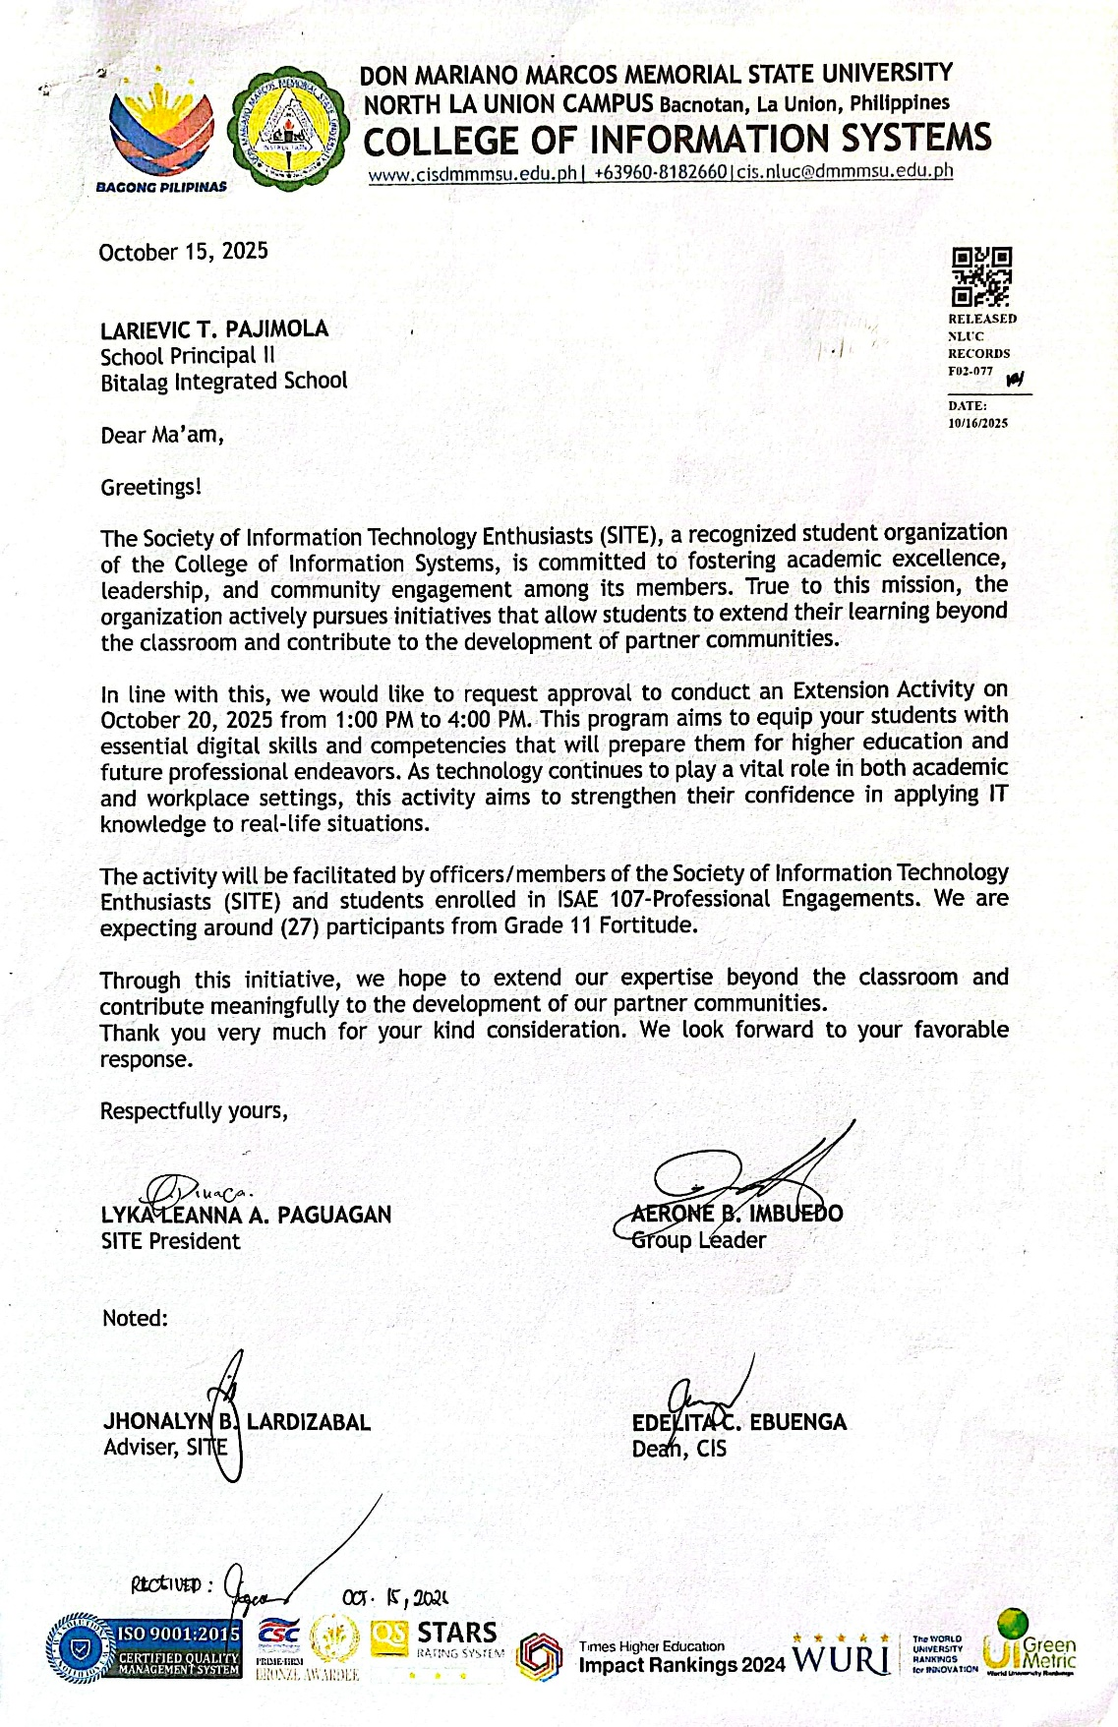

**APPENDIX B**

**PROGRAMME**

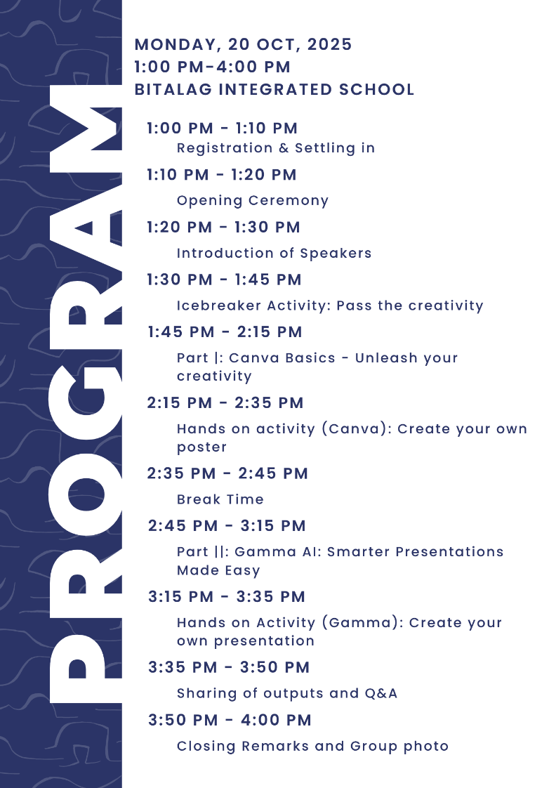

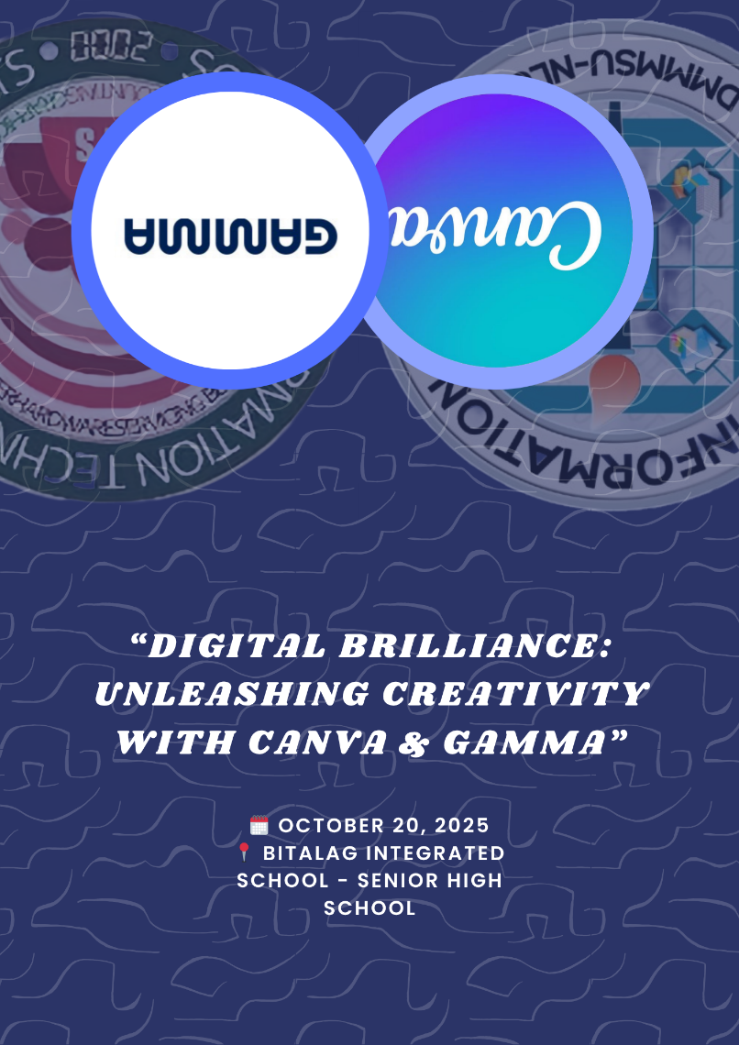

**APPENDIX C**

**PUBLICATION MATERIAL**

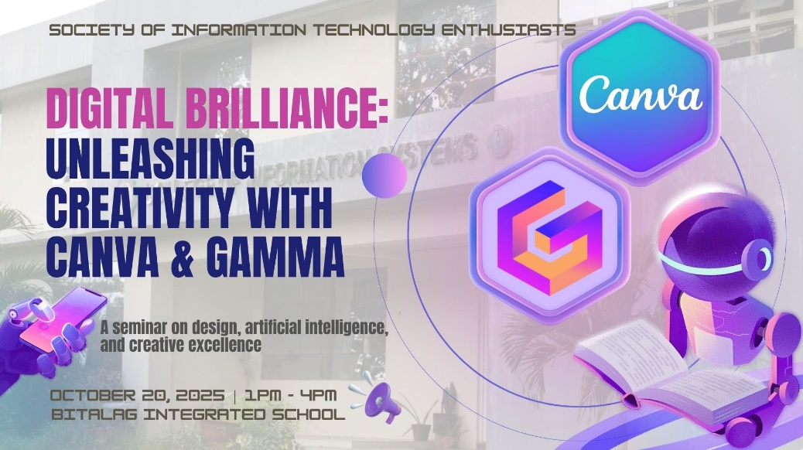

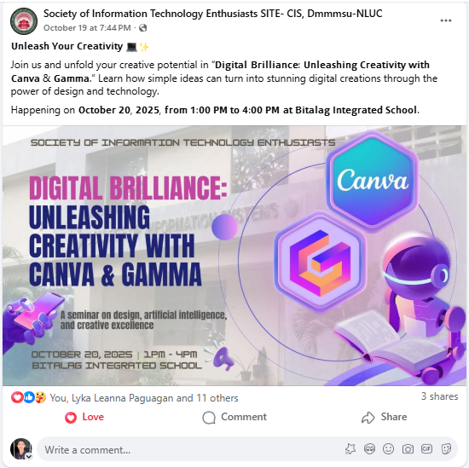

**APPENDIX D**

**CERTIFICATES OF RESOURCE SPEAKERS**

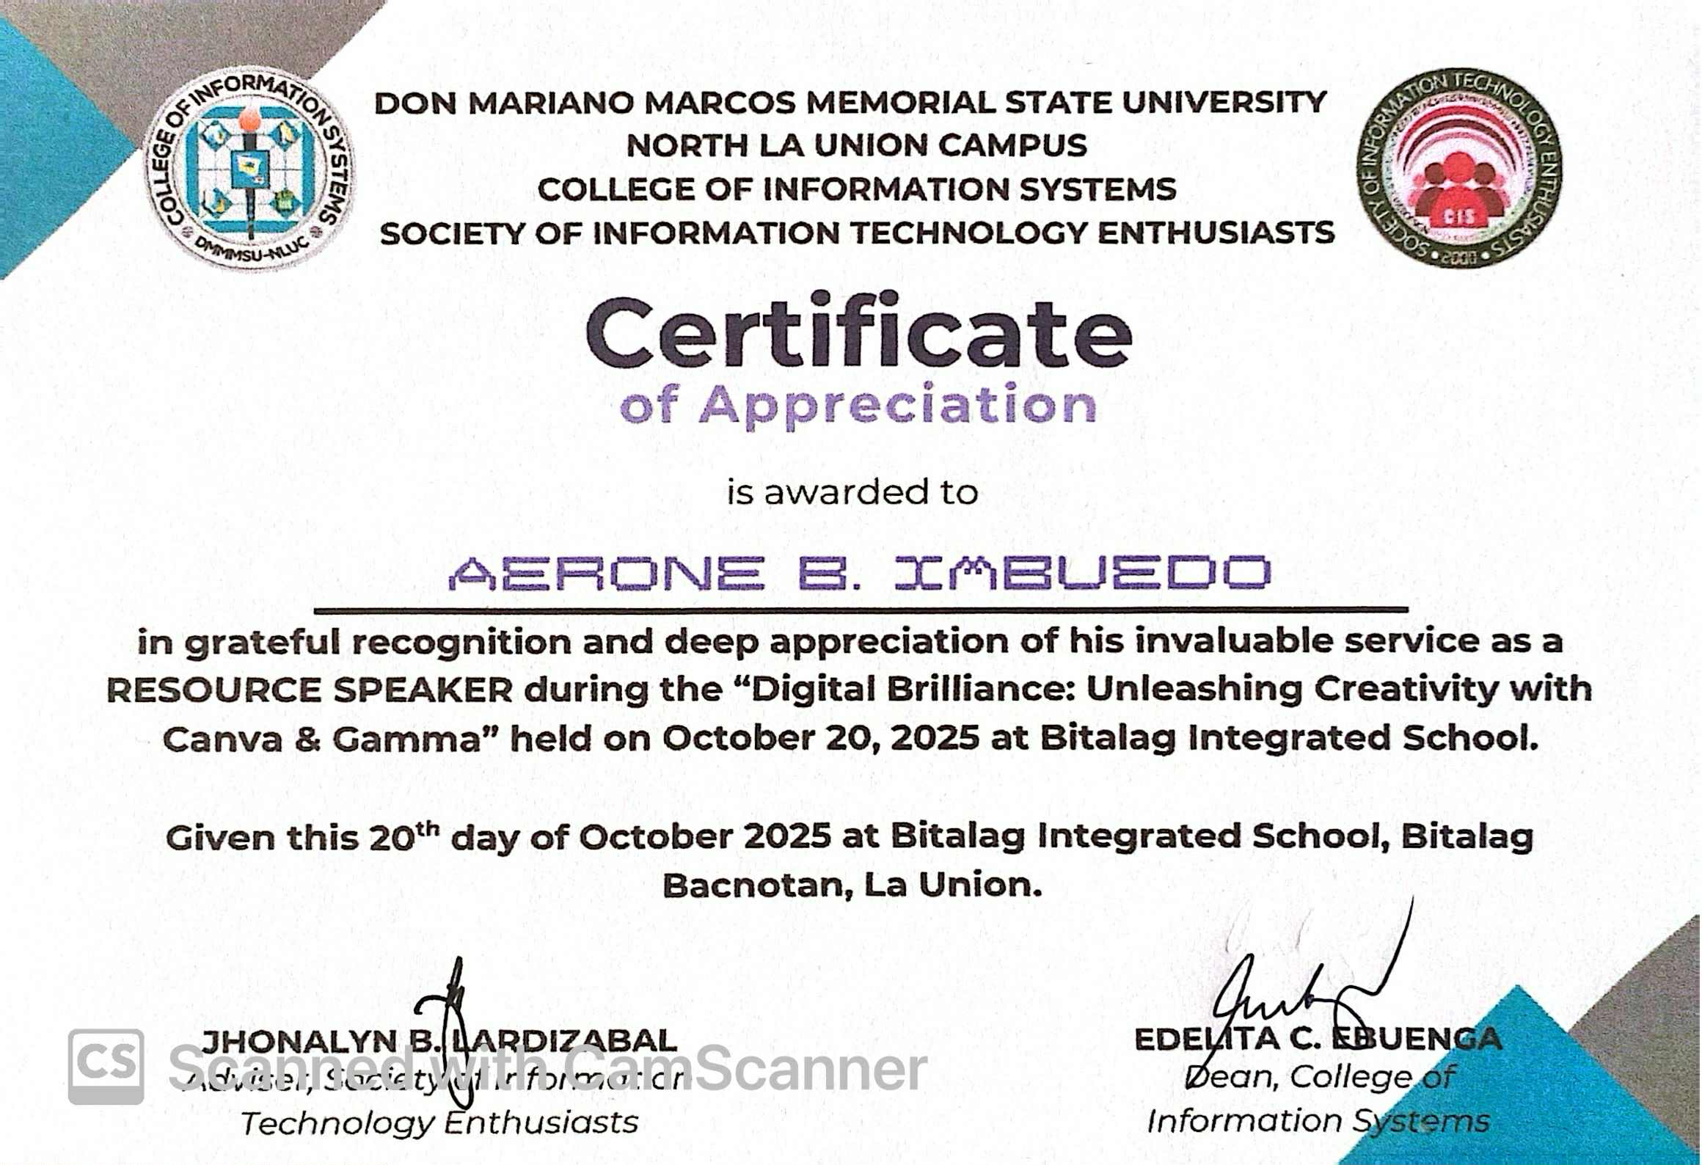

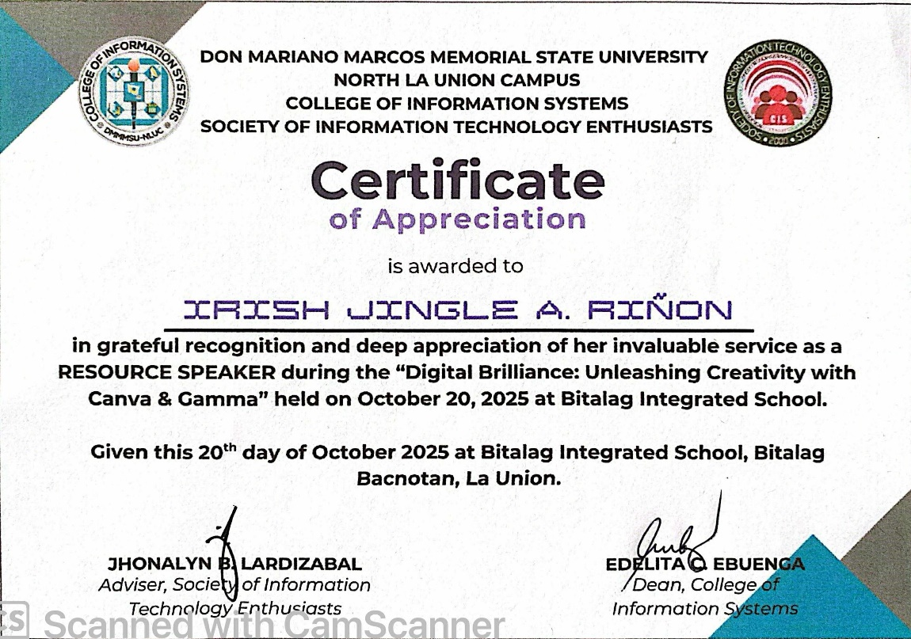

**APPENDIX E**

**CERTIFICATES OF FACILITATOR**

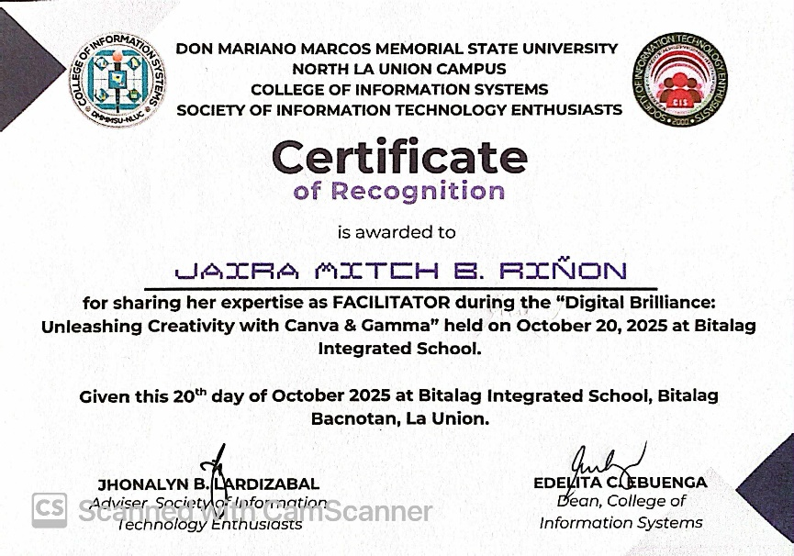

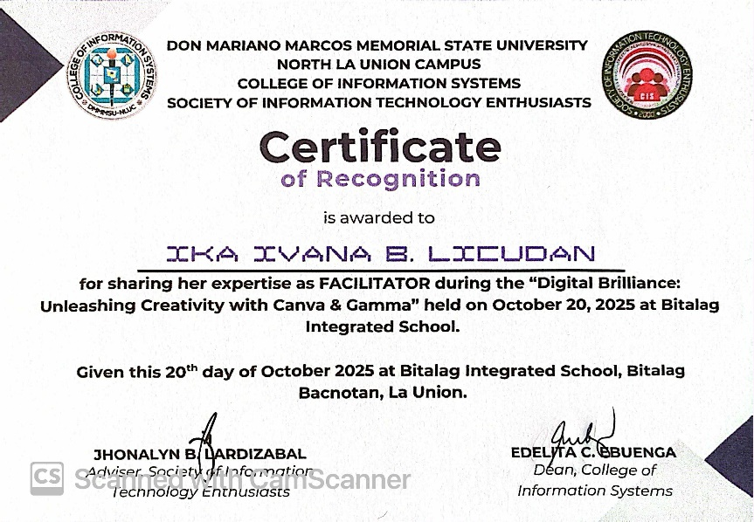

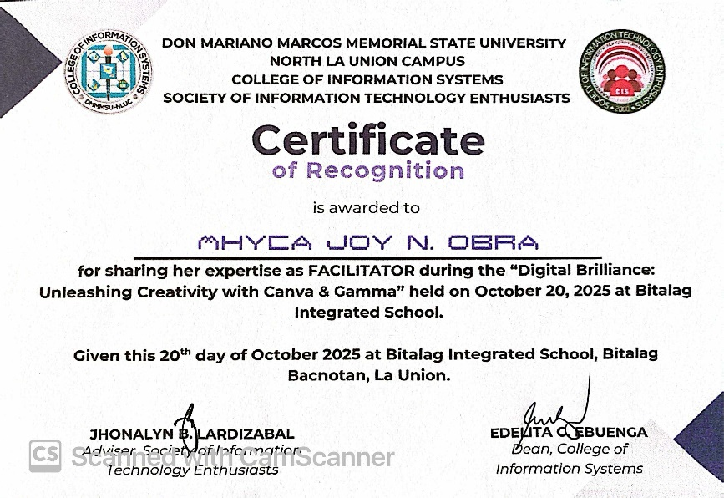

**APPENDIX F**

**CERTIFICATES PARTICIPANTS**

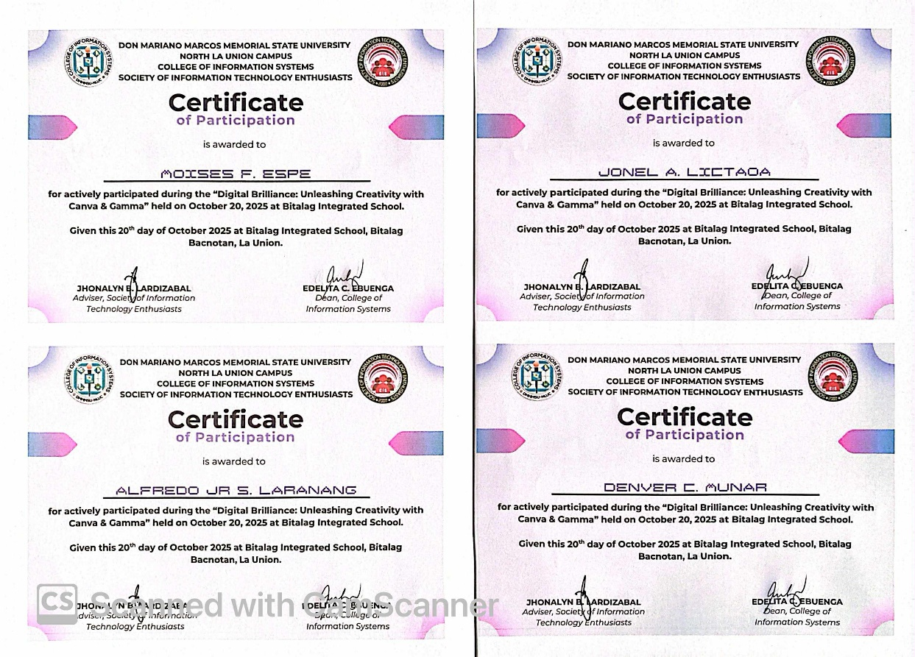

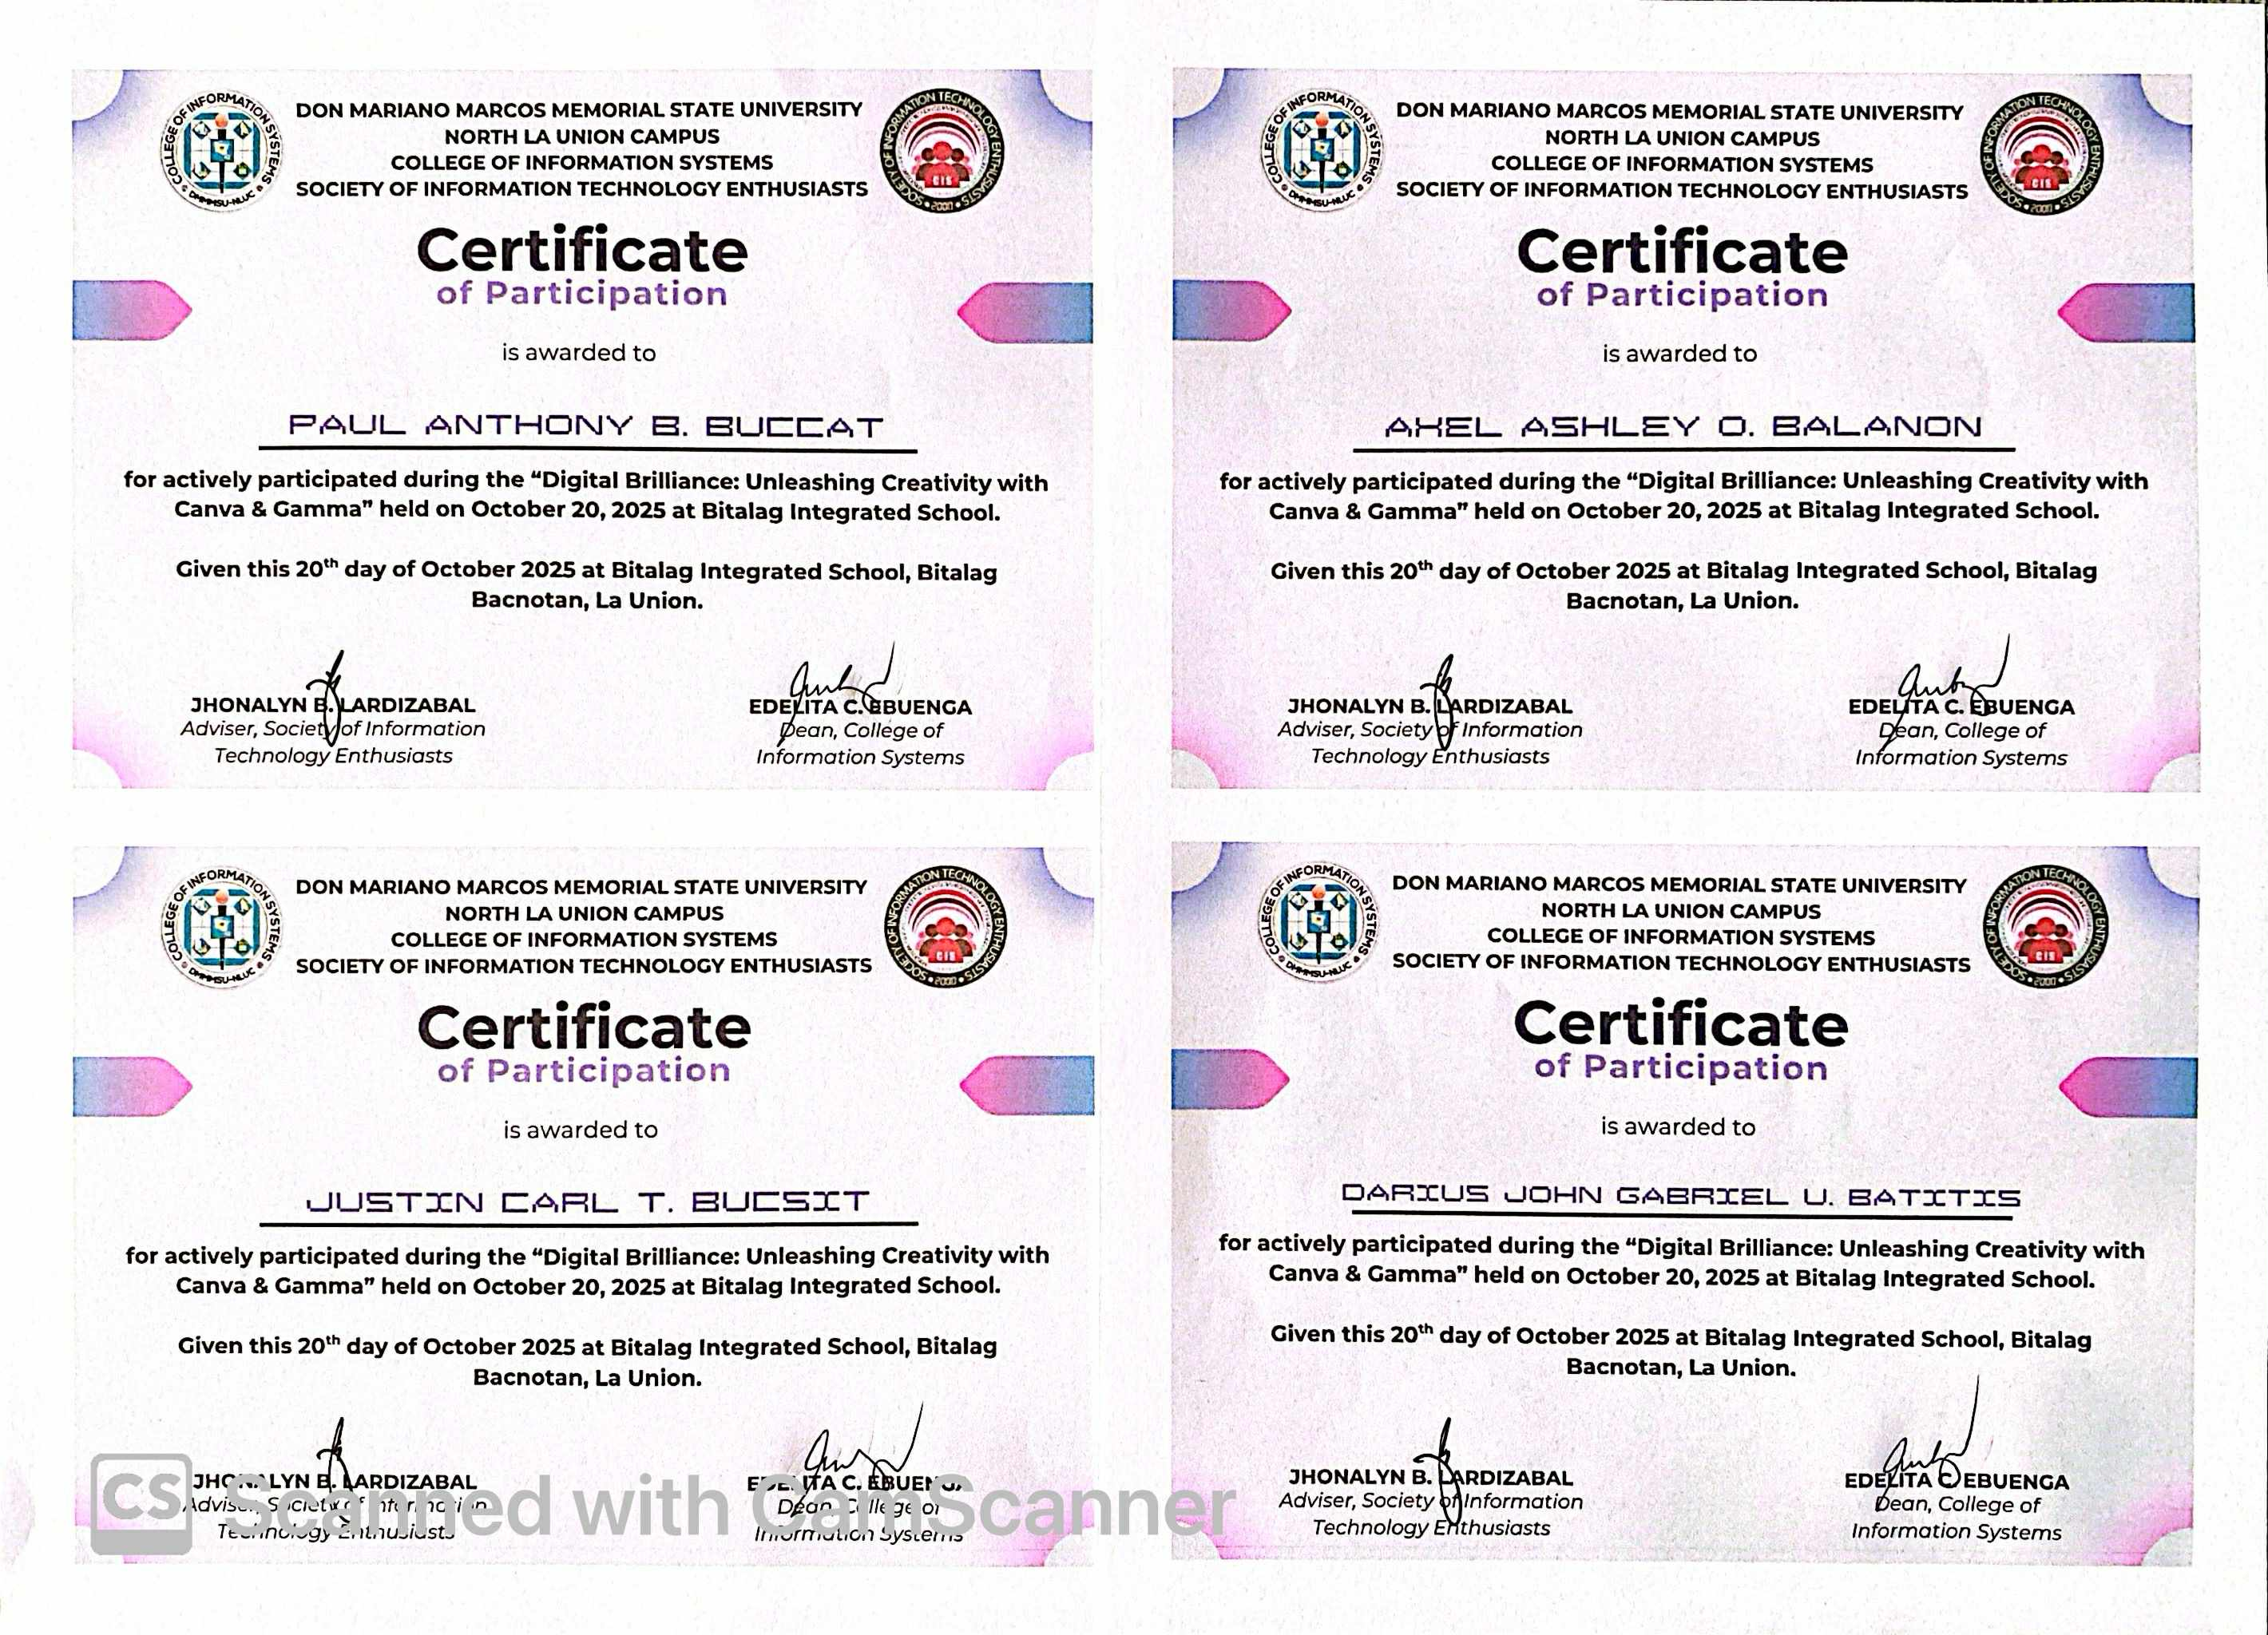

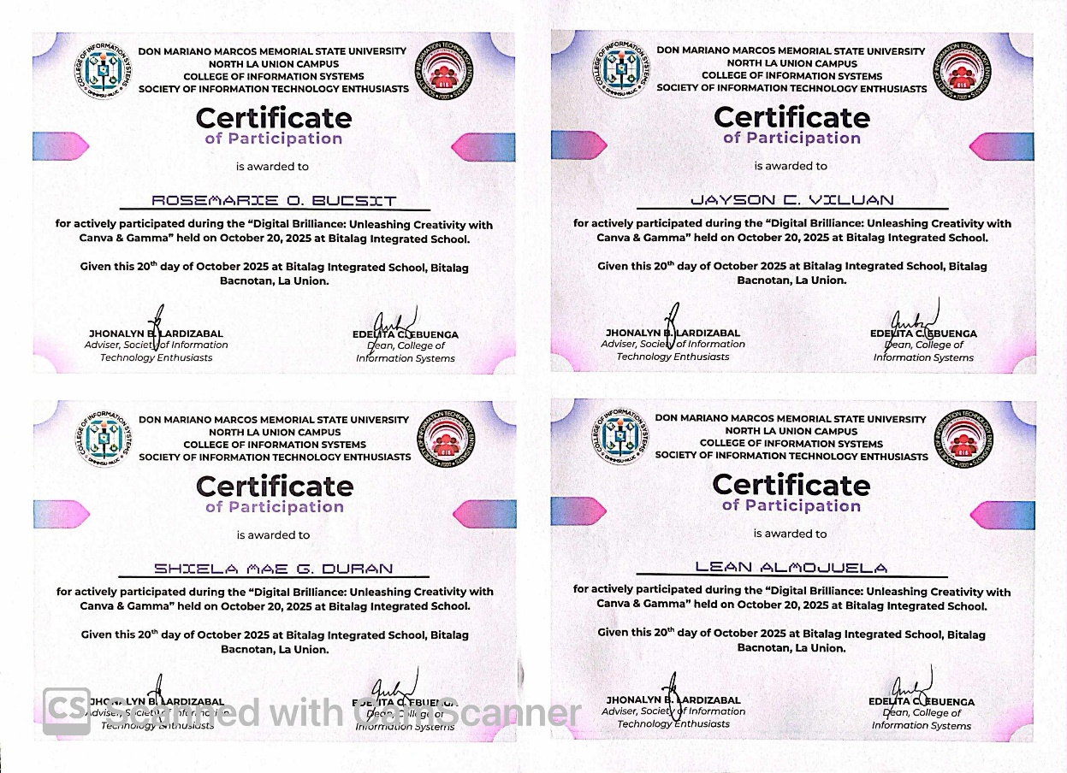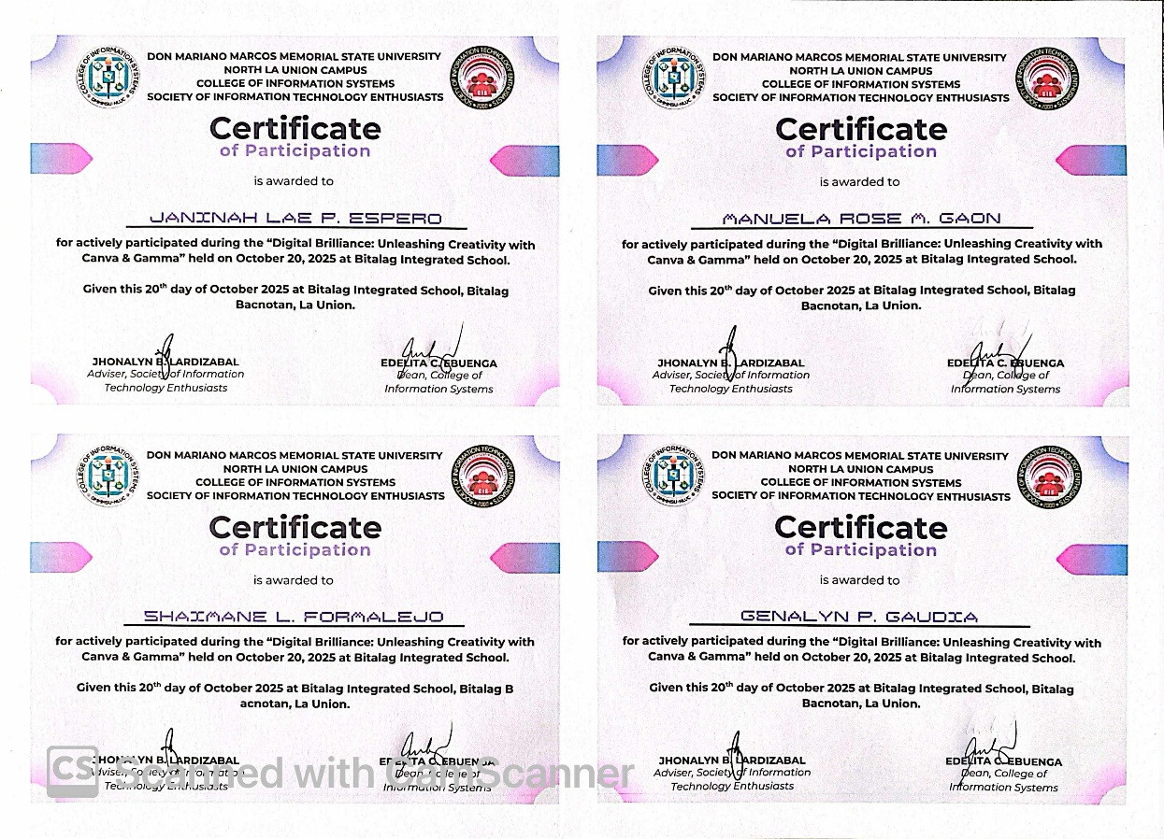

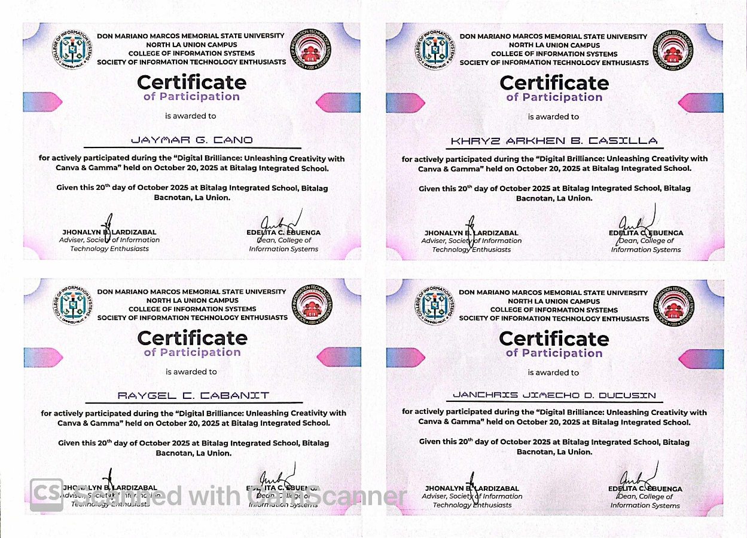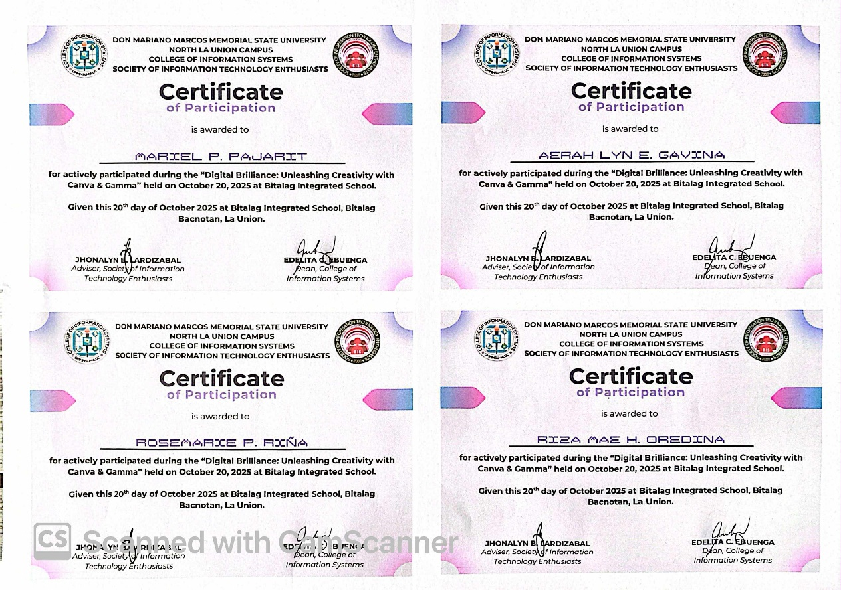

**APPENDIX G**

**ATTENDANCE**

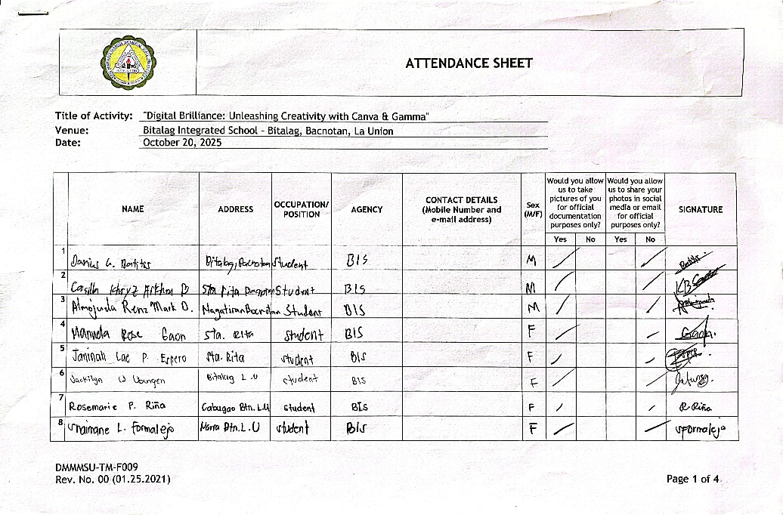

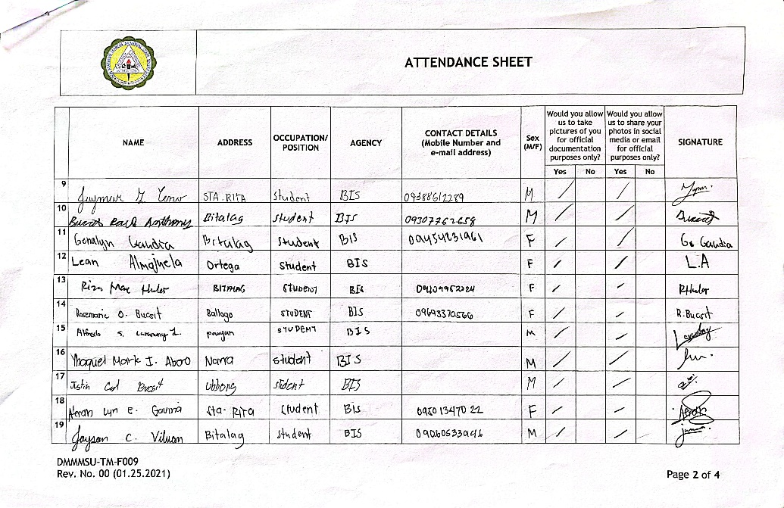

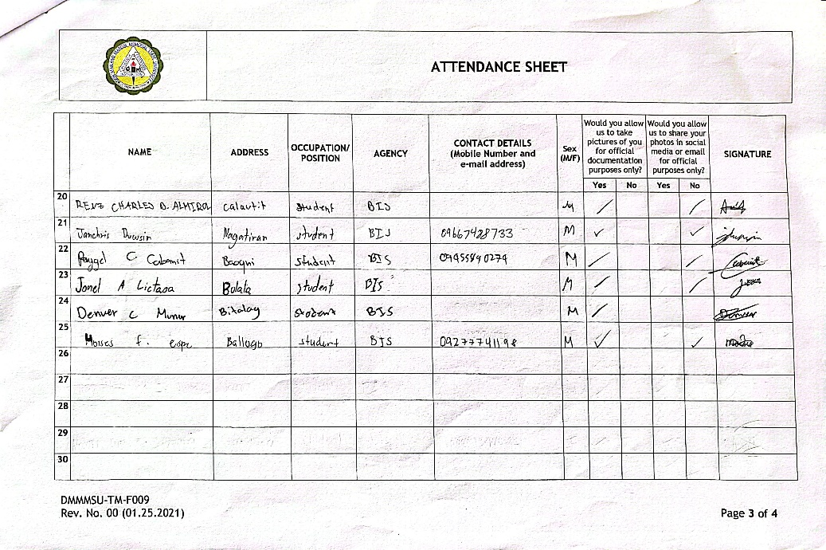

**APPENDIX H**

**STUDENT OUTPUTS**

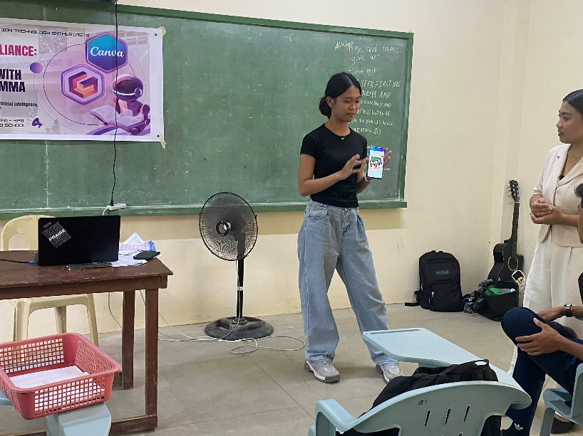

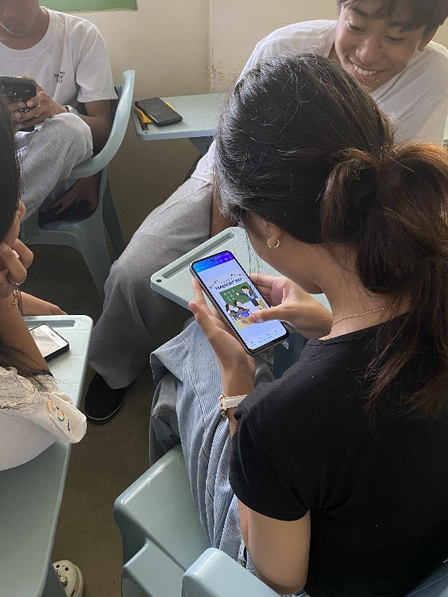

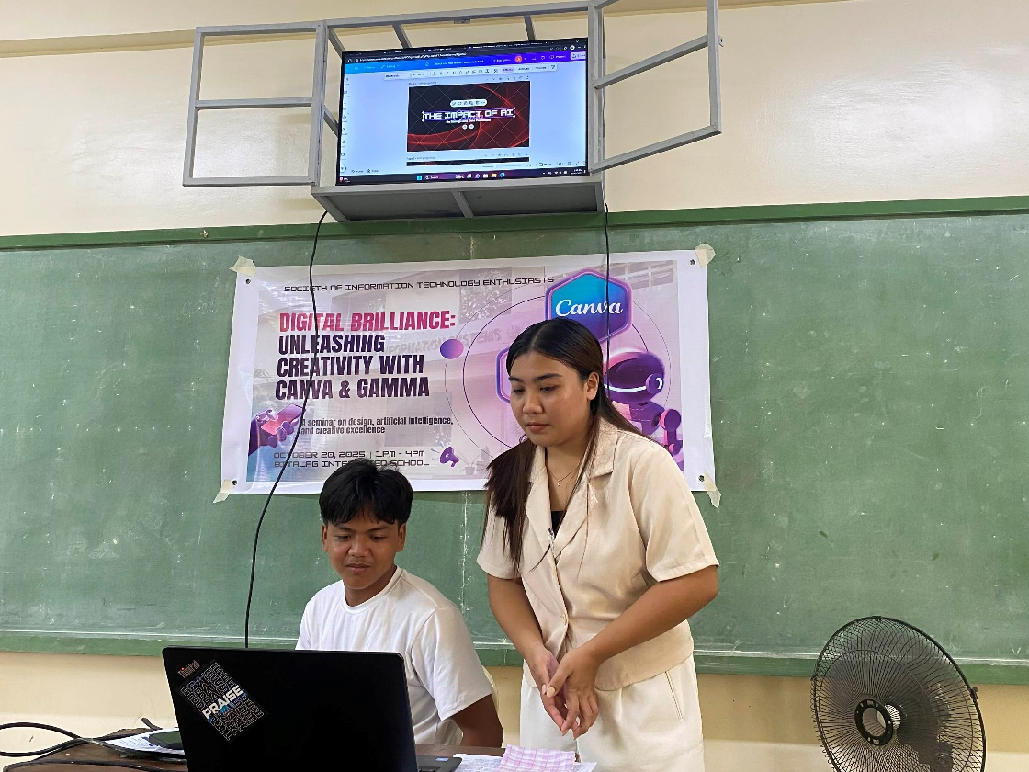

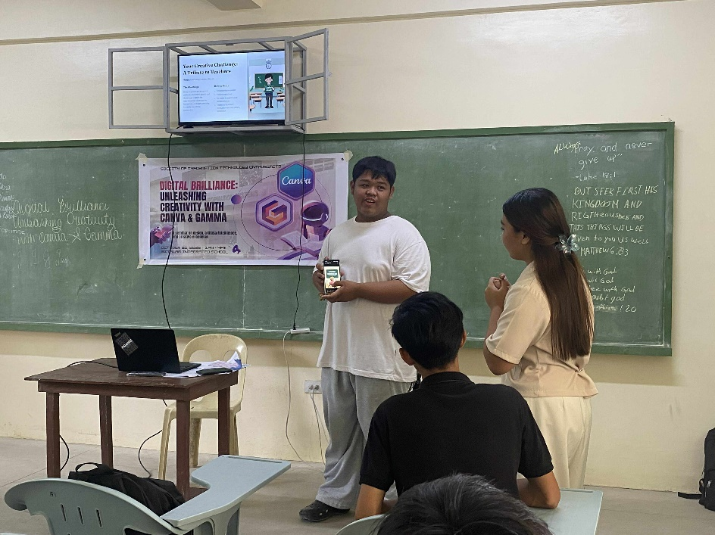

**APPENDIX I**

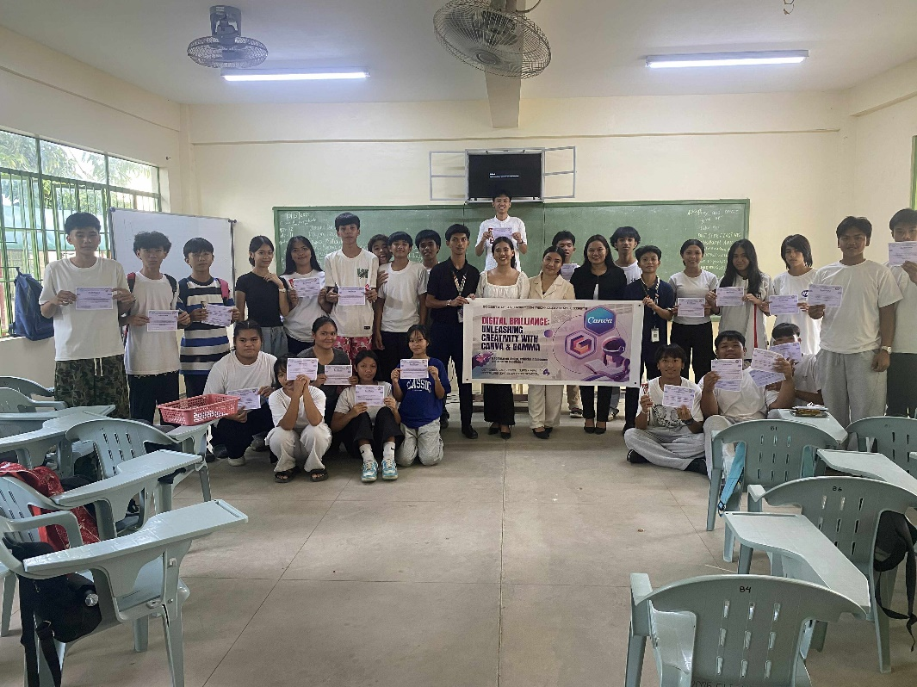**PHOTO DOCUMENTATION**

